**EXPERIMENT 8**

**Create a Virtual Hard Disk and allocate the storage using VM ware Workstation**

Step 1: Create a new virtual Machine

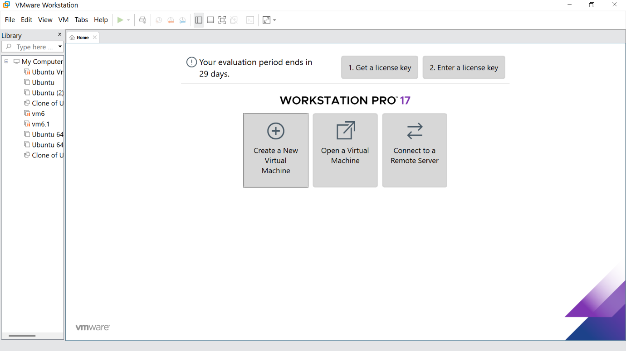

Step 2: Click the Typical option and click Next

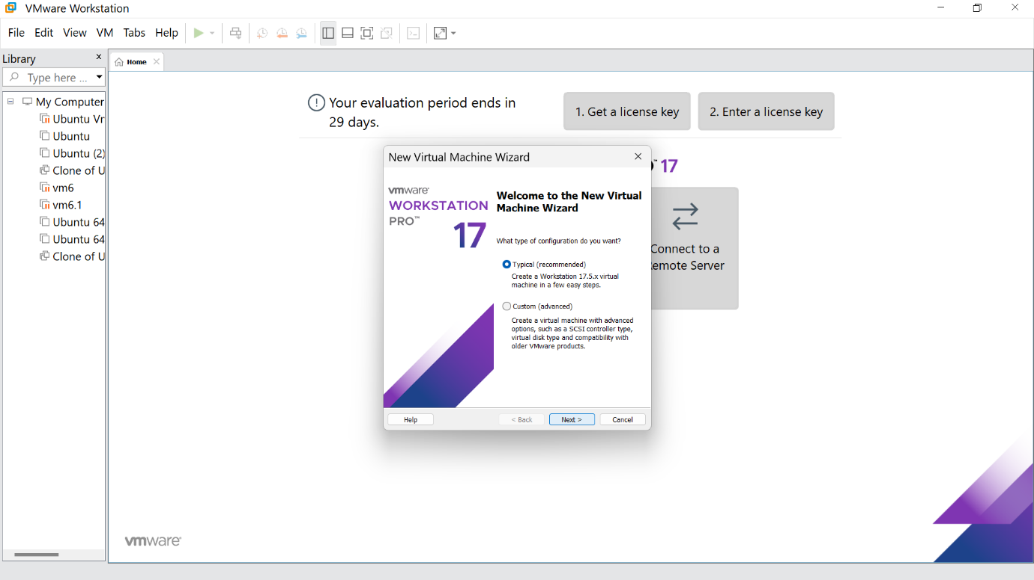

Step 3:Click the install option and proceed to the next step

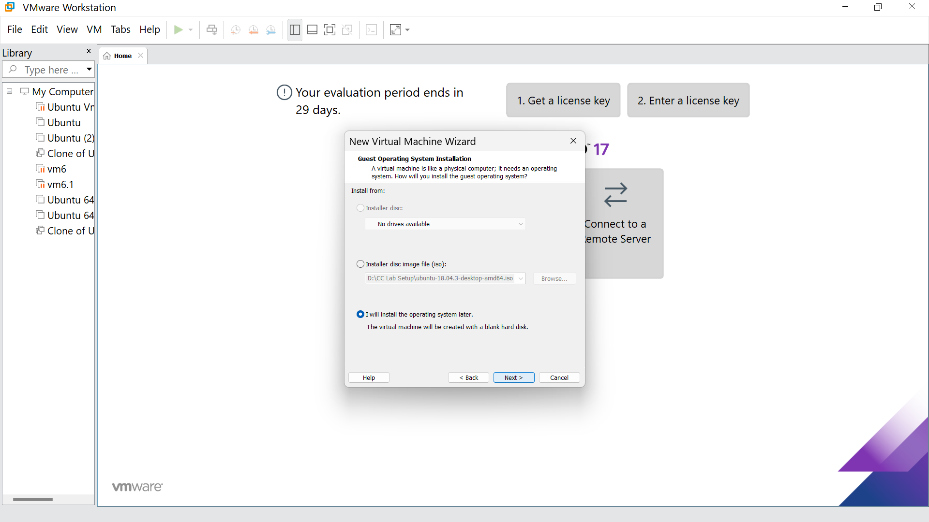

Step 4: Select the Linux option and click Next

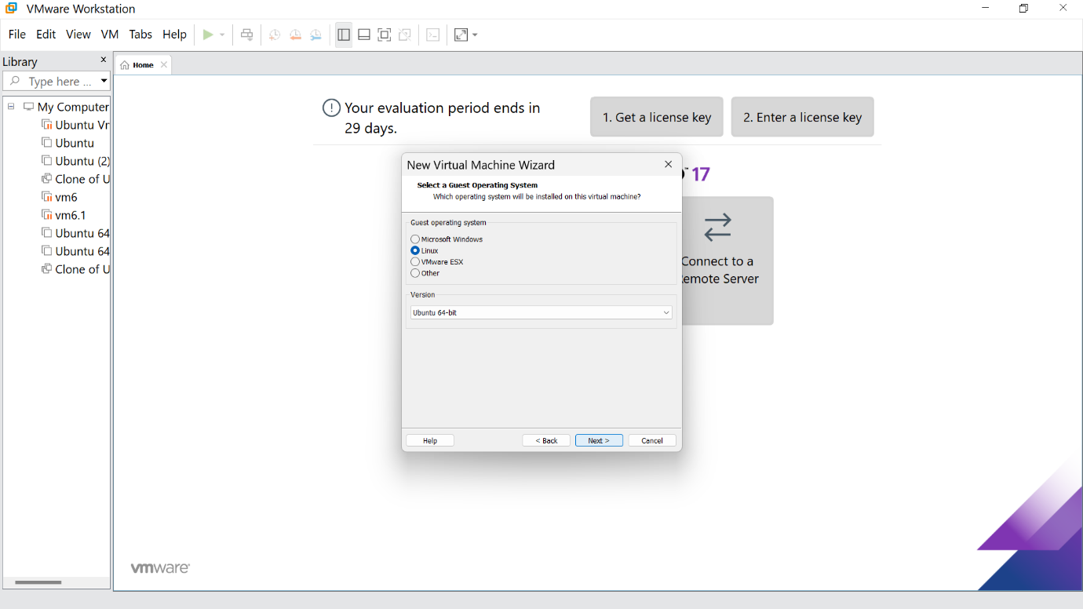

Step 5: Give the name for the virtual machine(optional) and click next

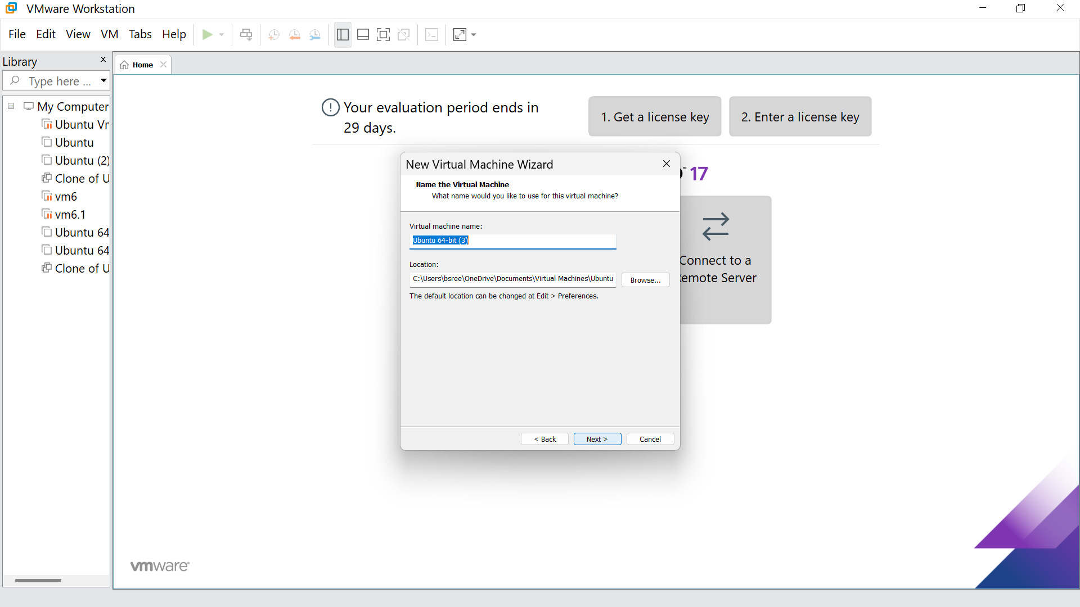

Step 6: Select the option to store the disk in a single file and click next

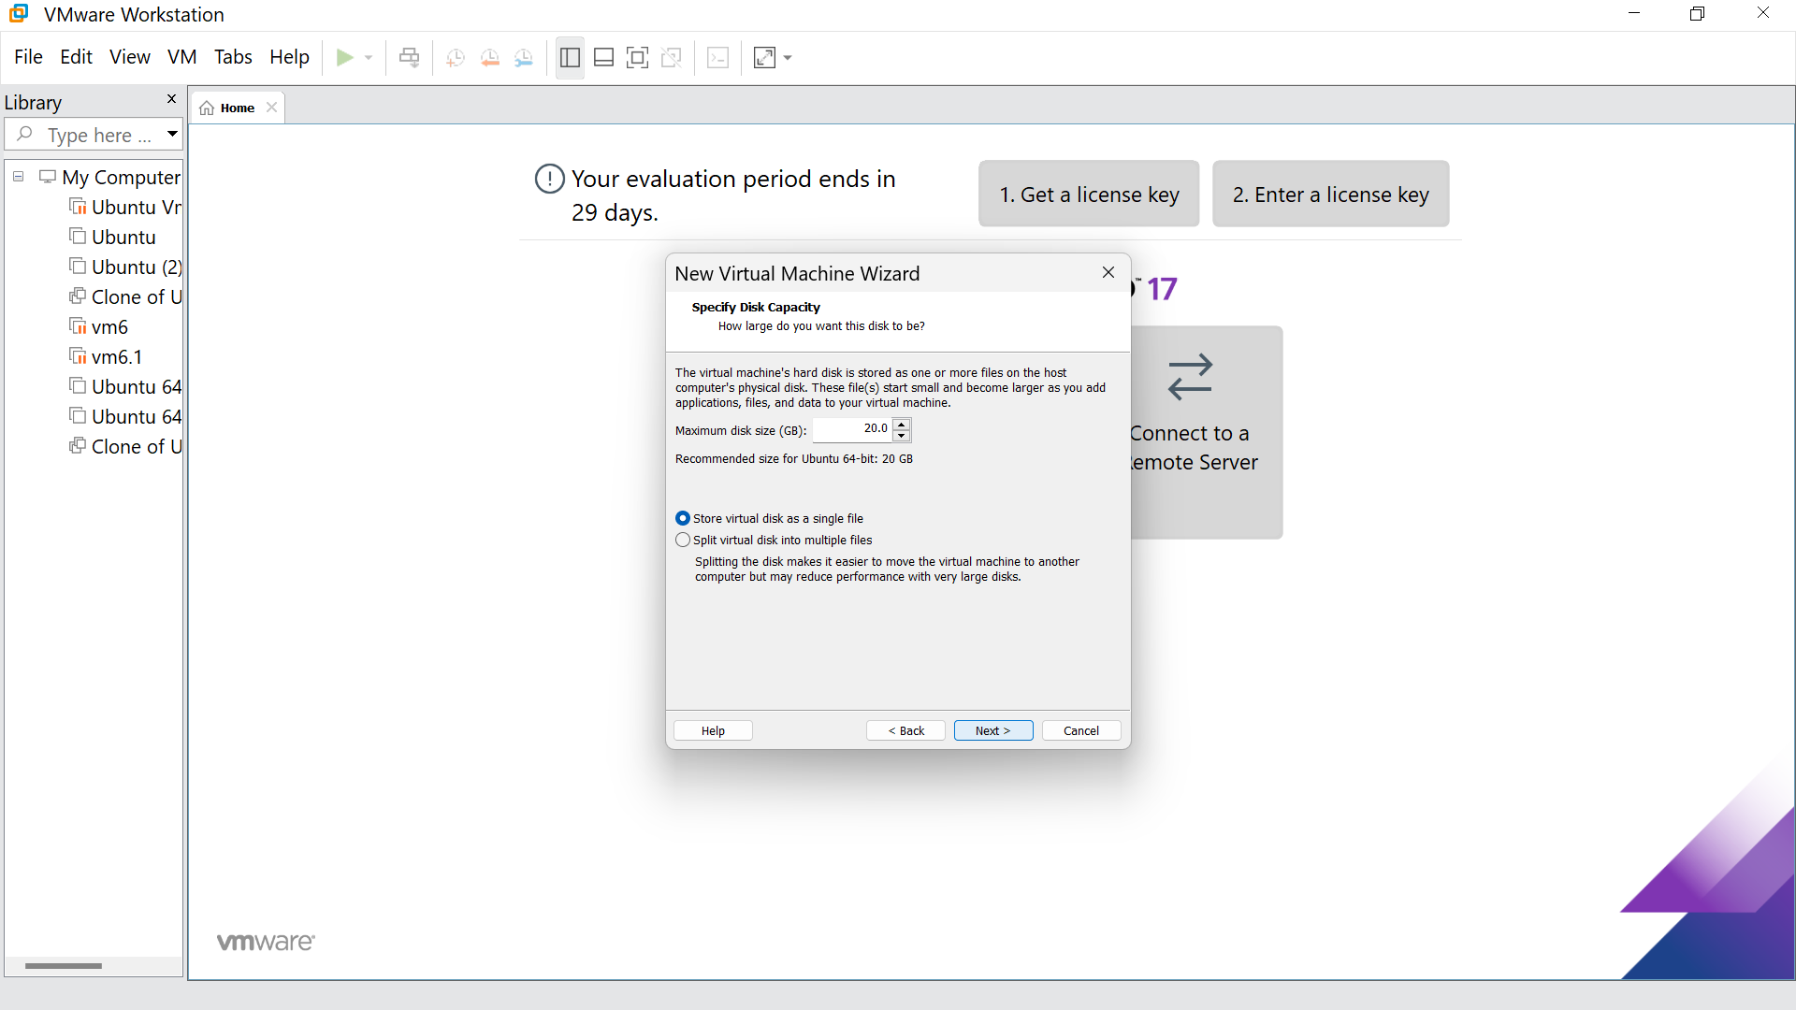

Step7:Our new VM is ready, click Finish

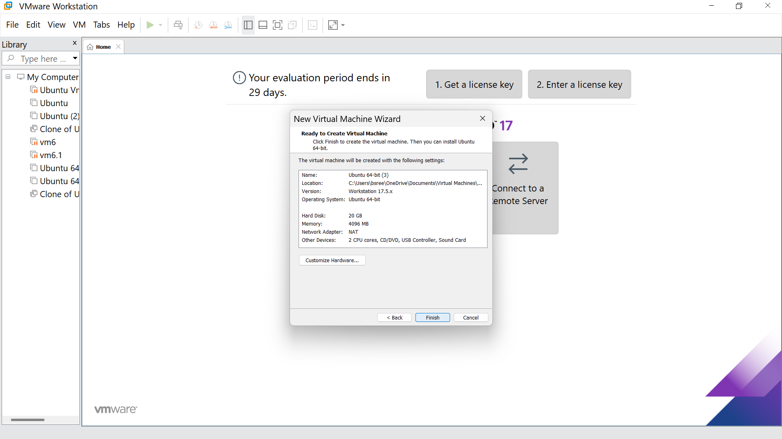

Step 8: This is the creation of a VM

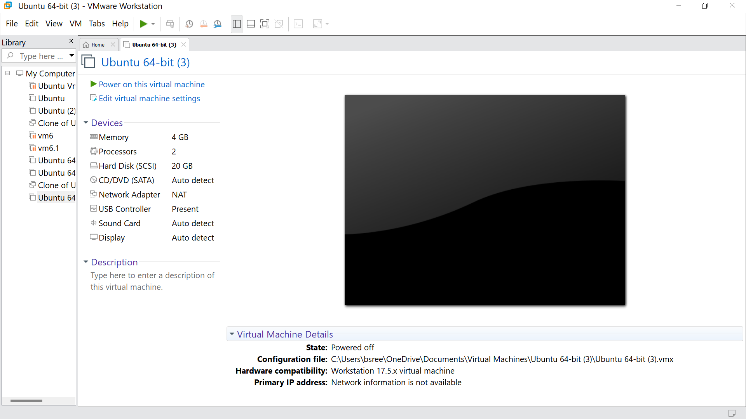

Step 9: Go to hard disk, click on add

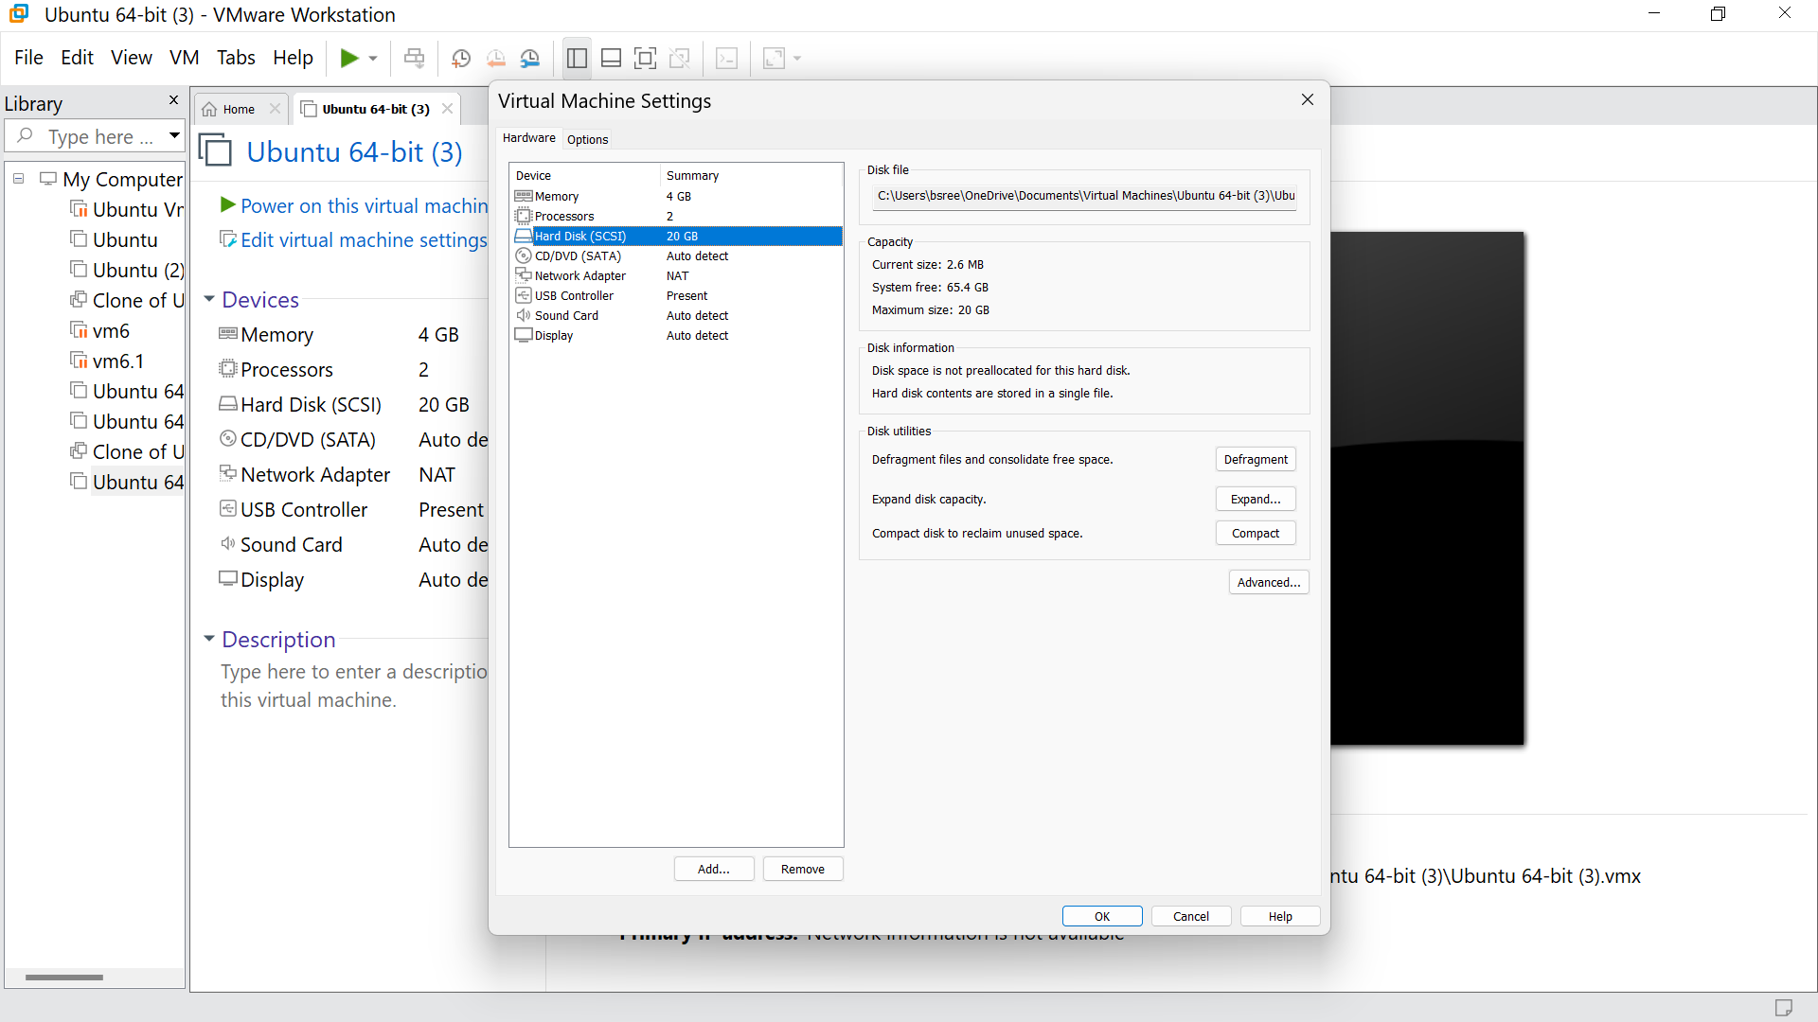

Step 10: click on next

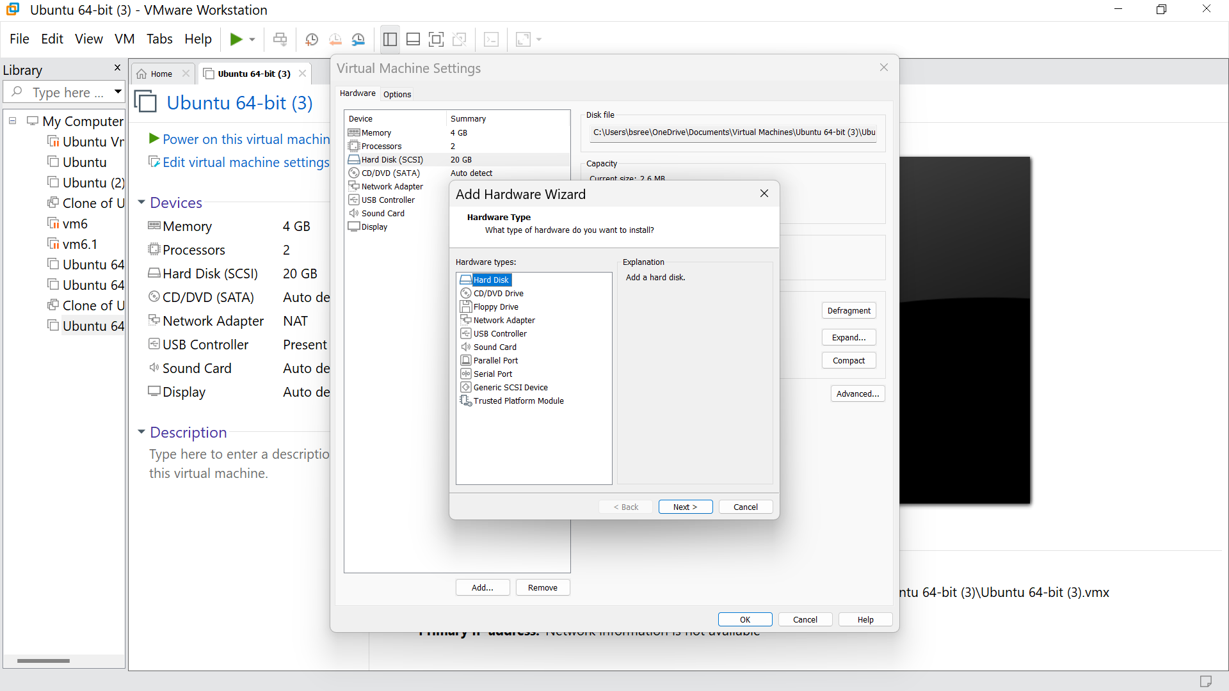

Step 11: Choose the SCSI option and click next

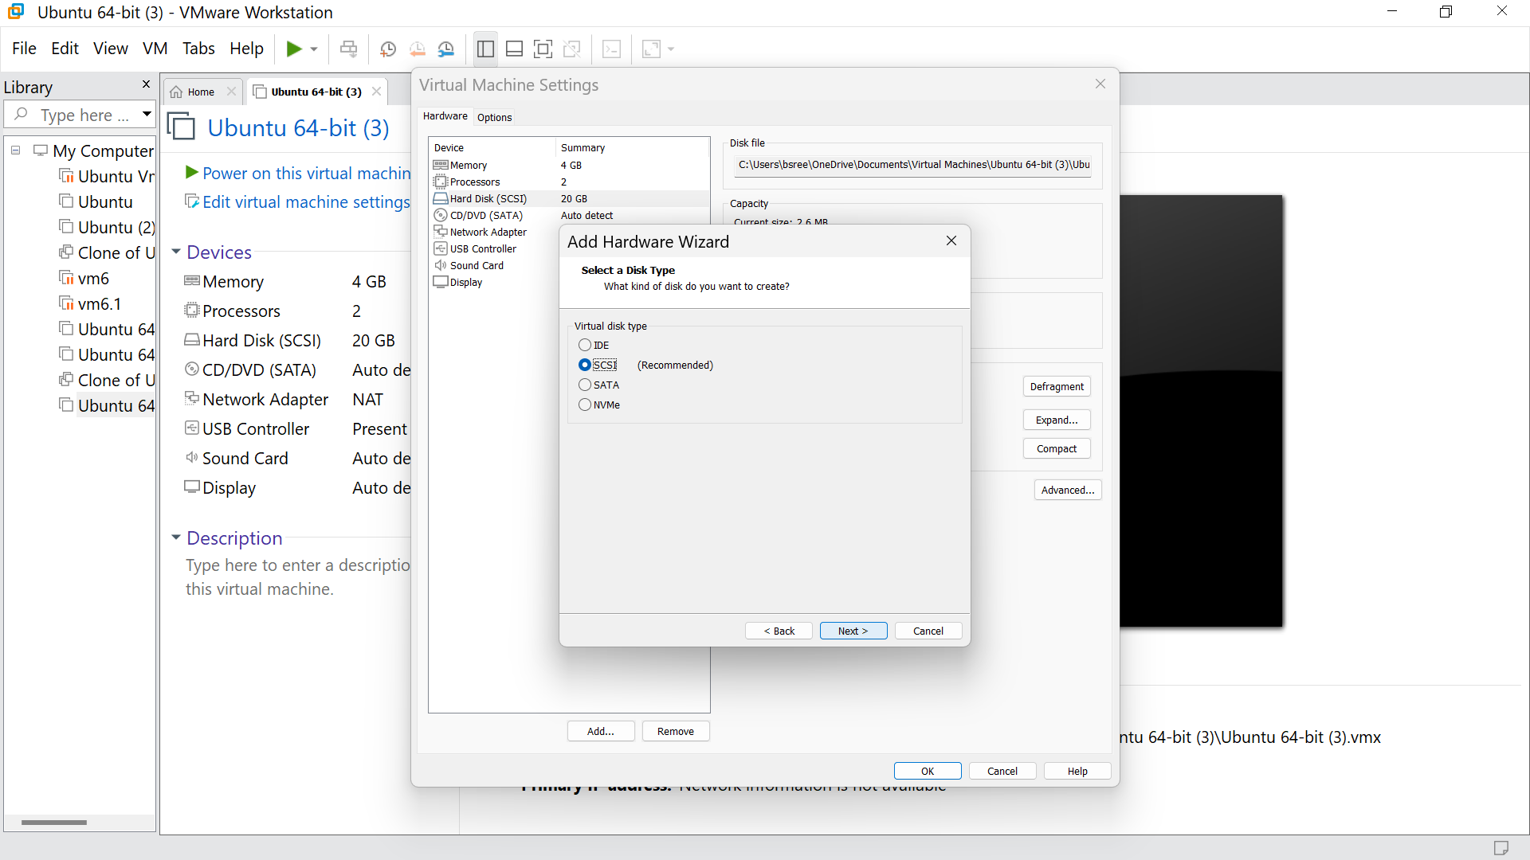

Step 12: Click on ‘create a new virtual disk option’, and click next

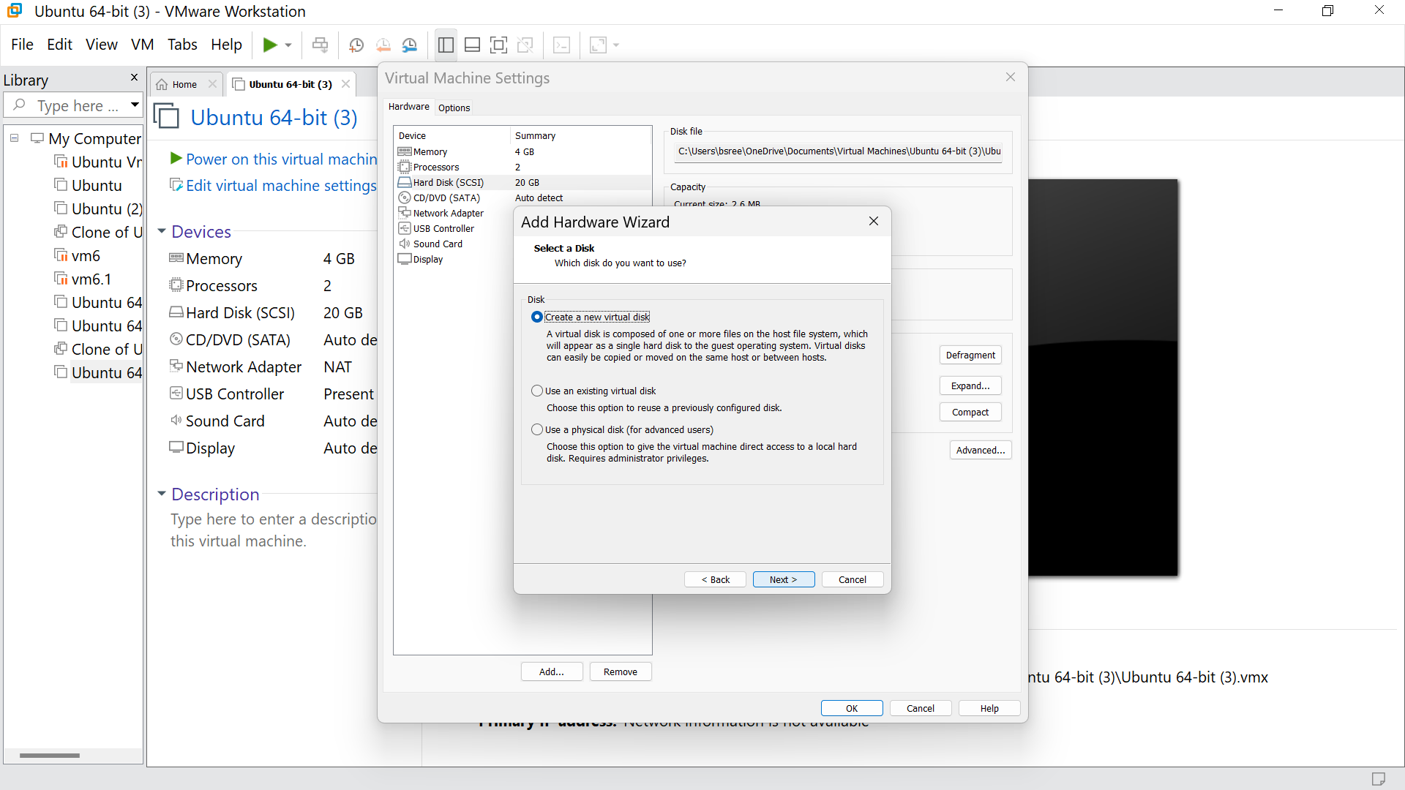

Step 13:Set the required GB for the HardDisk. And click next

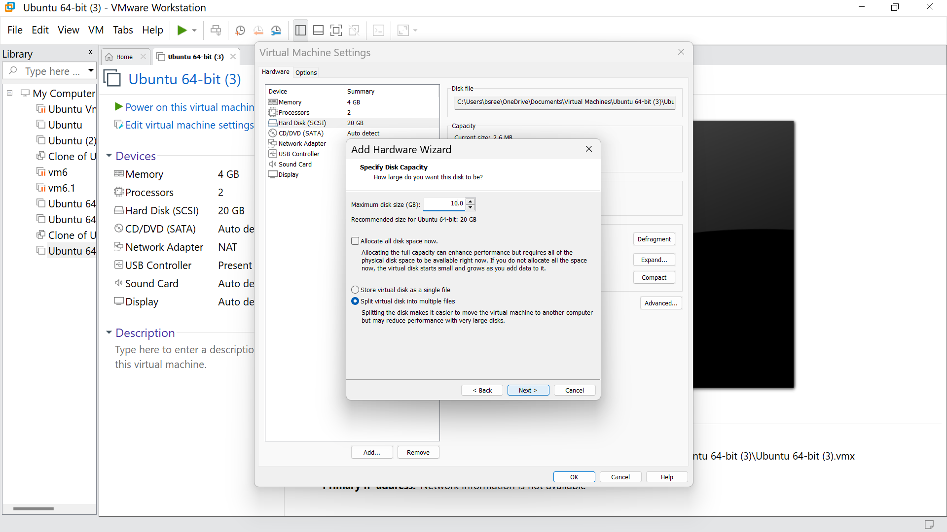

Step 14 : To add the HardWare click finish

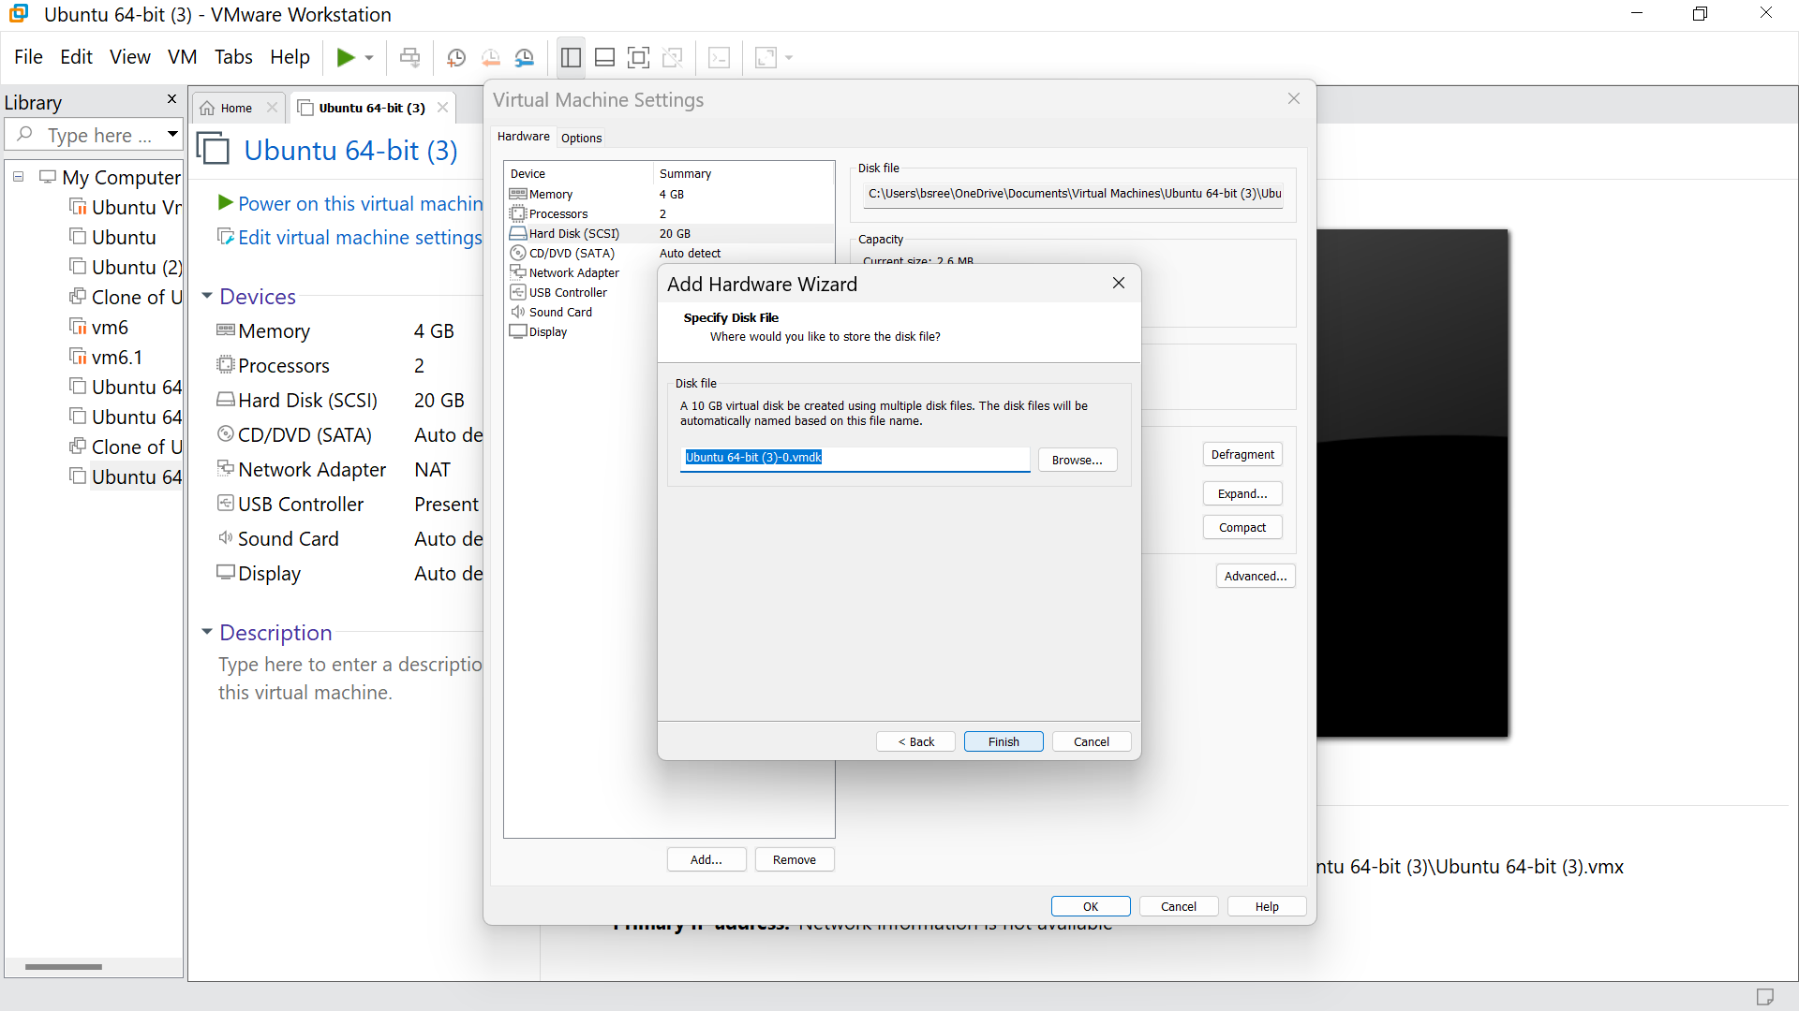

Step 15: Click ok

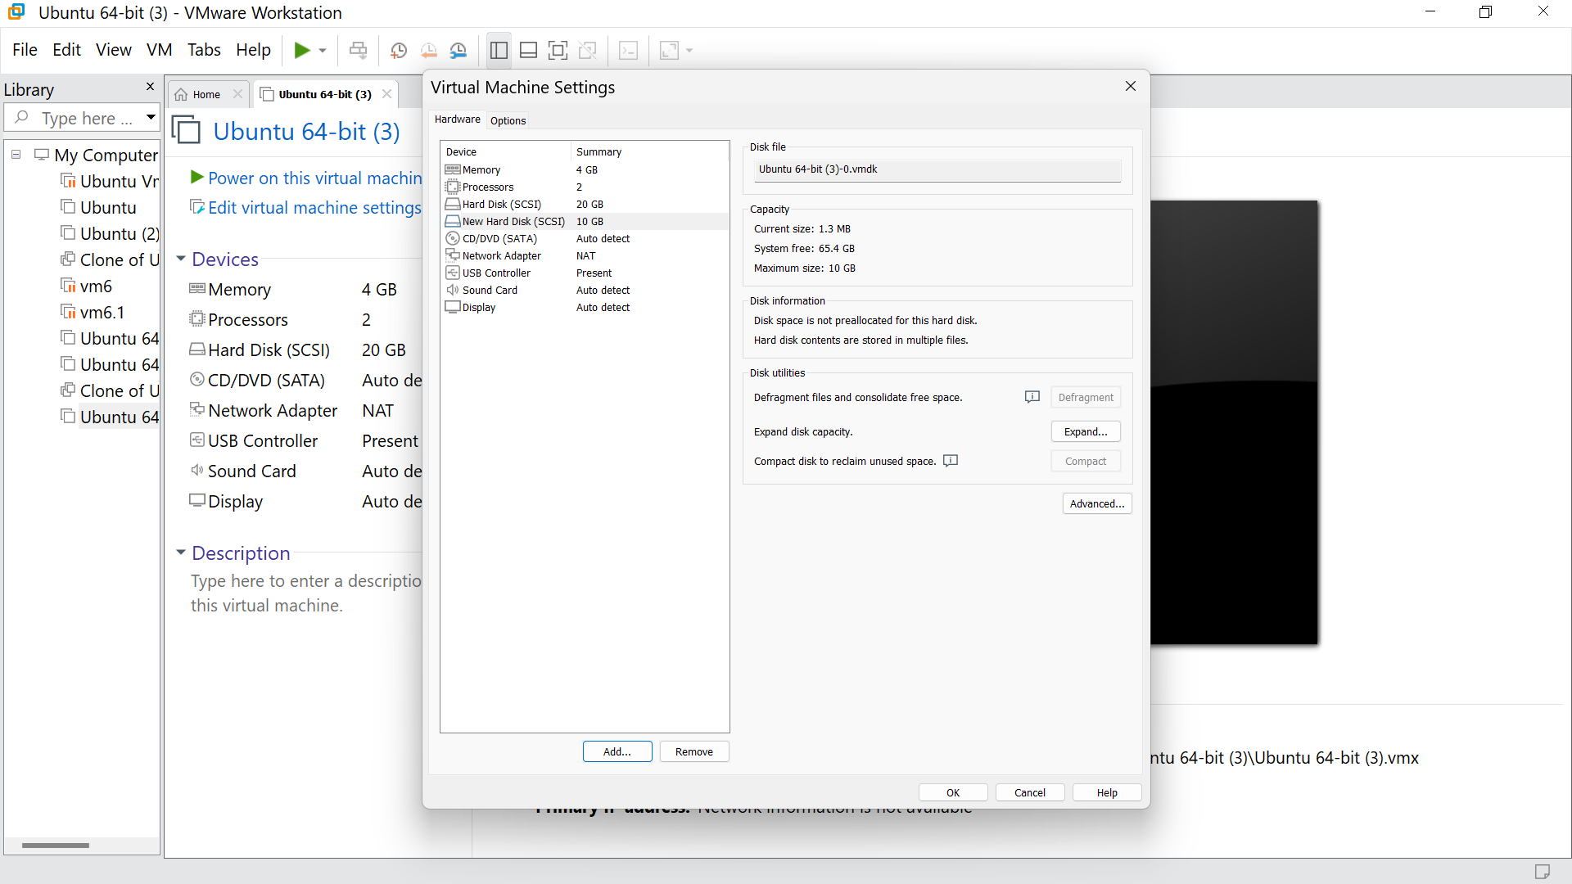

Step 16 : Hence we got the output

